Lab Assignment # 1

Name of Student : Kesoju Saikiran
Enrollment No. : 2303A51539
Batch No. : 22

Task 1: AI-Generated Logic Without Modularization (Factorial without
Functions)

Prompt:-
Write a simple Python program to find the factorial of a number using loops, without using any functions.
Code:-
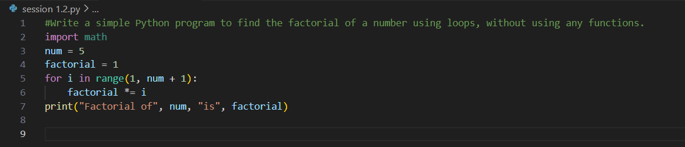

Output:-

Justification:-
This code solves the problem in a very straightforward way by writing everything in one place. It is easy for beginners to understand and good for small tasks. However, since it does not use functions, the code cannot be reused easily in bigger programs.

Task 2: AI Code Optimization & Cleanup (Improving Efficiency)

Prompt:-
Improve the above factorial program by making the code simpler, removing extra variables, and making it easier to read.

Code:-

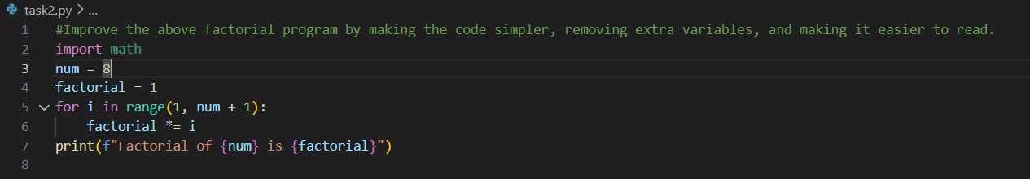

Output:-

Justification:-

This improved version looks cleaner and more organized. It removes unnecessary parts and focuses only on what is needed. Such clean code is easier to understand, debug, and maintain, especially when working with others.

Task 3: Modular Design Using AI Assistance (Factorial with Functions)

Prompt:-
Write a Python program to calculate the factorial of a number using a function.
Code:-
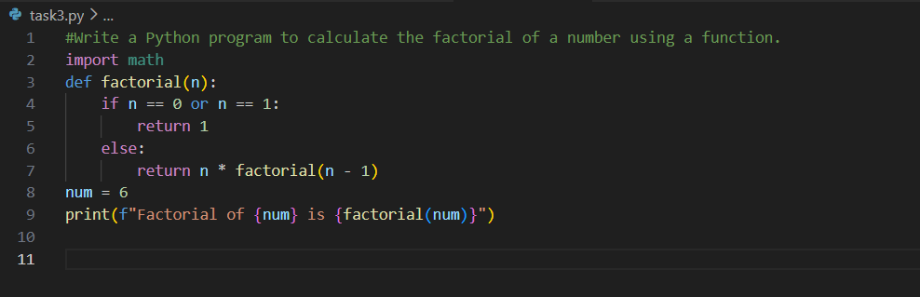

Output:-
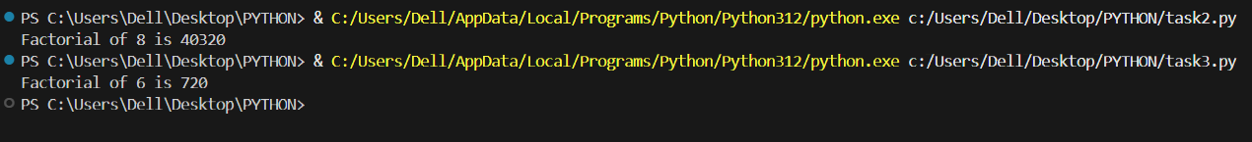

Justification:-
Using a function makes the program more structured and professional. The factorial logic is separated from the main code, which makes it reusable and easy to modify later. This is a better approach for larger programs.

Task 4: Comparative Analysis – Procedural vs Modular AI Code (With vs
Without Functions)

Prompt:-
Write a program that compares factorial code written without functions and with functions, and explain which one is better in terms of understanding, reuse, debugging, and use in large projects. Show the comparison in a small table.
Code:-
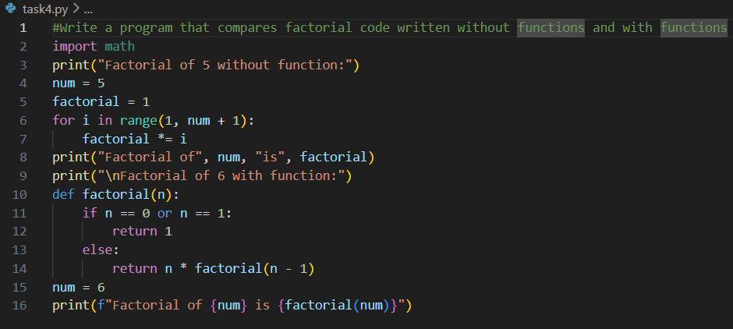

Output:-
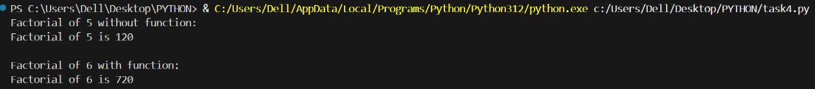

Justification:-

This comparison helps us clearly see the advantages of using functions. Code with functions is easier to understand and debug and can be reused in many places. It is more suitable for large and real-world applications than single-block code.

Task 5: AI-Generated Iterative vs Recursive Thinking

Prompt:-
Write a program that calculates factorial using both iterative and recursive methods, explain how each one works, and compare them based on readability, memory usage, performance, and limitations.

Code:-
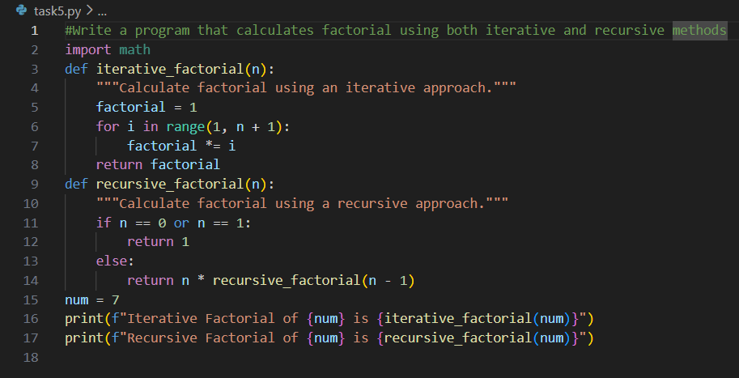

Output:-

Justification:-

This task shows two different ways of solving the same problem. The iterative method is simple and safe for large numbers, while the recursive method is easier to understand logically but can cause memory issues for big inputs. Knowing both methods helps in choosing the right solution..

